沃森实业有限公司
加拿大Walsn公司是致力于设计、生产环境排放、过程控制、燃烧效率及温度测量仪器产品的供应商。通过实践证明，Walsn生产的监测仪器是值得客户信赖和一直使用的放心产品。
为客户提供高质量产品是Walsn公司一惯追求的目标，它的所有产品都符合国际认证标准，同时Walsn拥有强大且专业的研发团队，所有成员都认真执守自己的岗位，确保每一个仪器的安全性及精密性，并以客户需求为己任，认真积极为客户问题提供满意的解决方案。Walsn的专业技术保证了电厂安全运行的持久性。
Walsn基于对电厂燃烧过程控制及燃烧效率的热爱，使其很快成为行业佼佼者。Walsn生产的磨煤机防爆监测系统、烟尘颗粒物监测仪、硫酸露点监测系统及烟道CO监测仪受到了全球客户的广泛认可。同时Walsn会根据社会发展与需求继续开发和生产新产品，以满足客户新的需求。
About Walsn:
WALSN specializes in the design and manufacture of temperature measurement, process, combustion efficiency and environmental emissions monitoring.
Quality is an integral part of the WALSN principle, where all levels of management and employees are responsible for the quality of their work, to ensure complete customer satisfaction.
With the interest in the efficiency of power plant combustion processes, mill fire monitoring, quick development of CO monitors soon established WALSN as world leaders in this field.
Additional expertise was gained with the development of sophisticated plant safety equipment in the form of stack gas emission monitoring systems and mill fire detection.
With the recent increase in environmental concerns, the company has continued to develop and produce a range of high quality on-line fuel identification system for monitoring and complying with international standards.
WALSN is really professional in the field, constantly innovating to provide instruments and systems with the highest performance and reliability.

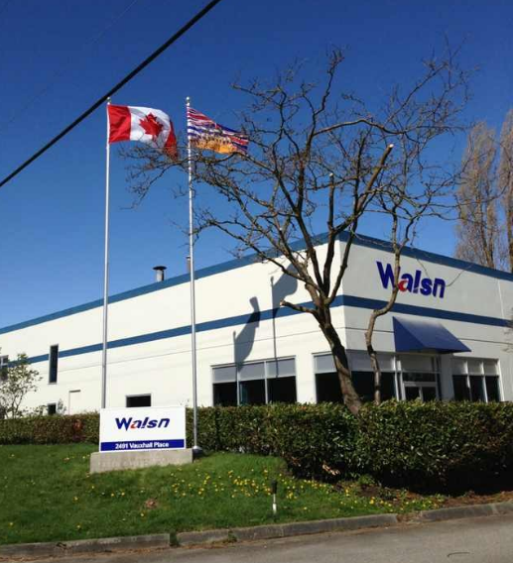

加拿大Walsn工厂
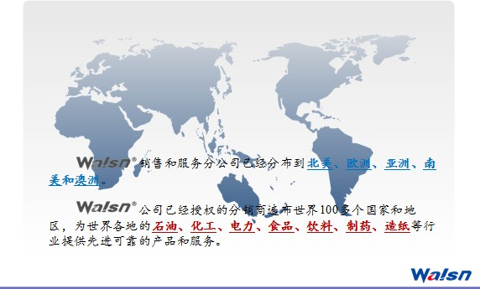

加拿大Walsn产品图片

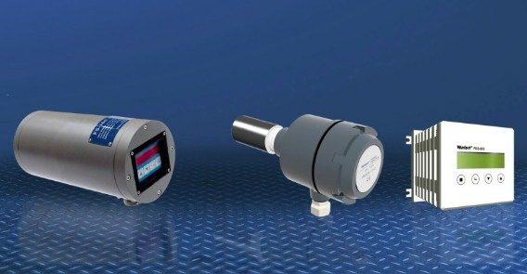
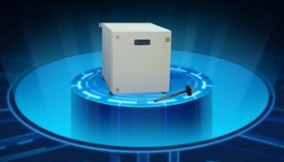
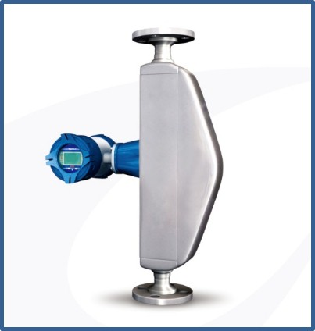

火焰检测器 磨煤机/筒仓CO检测系统 VS质量流量计

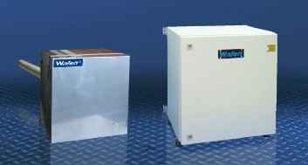
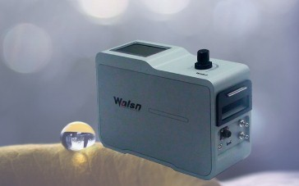
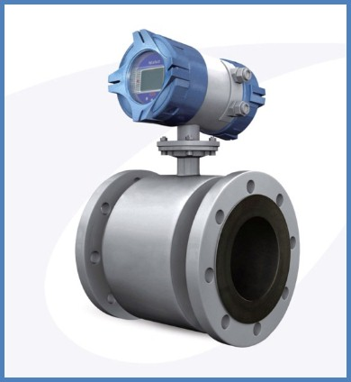

酸露点检测系统 燃烧效率检测系统 SX电磁流量计

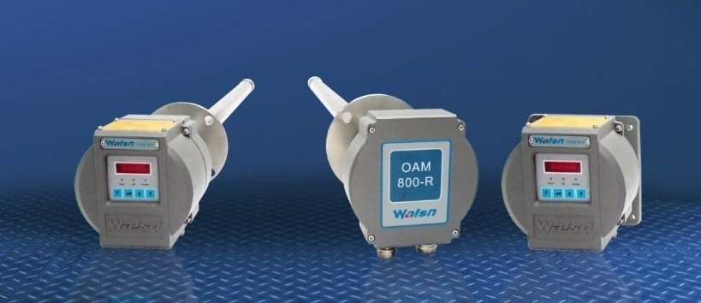
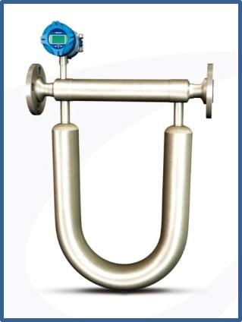
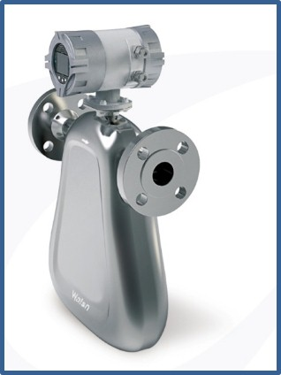

氧分析仪 TS质量流量计 US质量流量计

公司国内外合作伙伴
国家火力发电工程技术研究中心
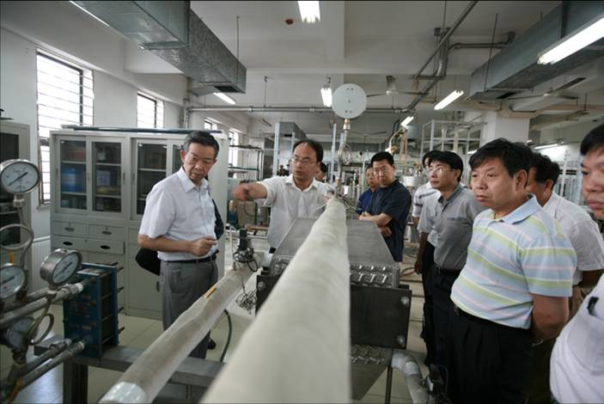
华北电力大学
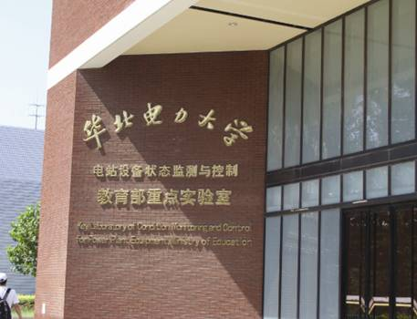
伊利诺伊理工大学

里贾纳大学


